0. terminal cli 단축키
sudo !! (뱅뱅) : 이전 명령을 sudo 명령어 자동 첨부

ctrl+a : 명령줄 맨 앞으로 커서이동
ctrl+e : 명령줄 맨 뒤로 커서이동
ctrl+l : clear와 같은 단축키
ctrl+k : 커서 뒤쪽 잘라내기(지우기)
ctrl+u : 커서 앞쪽 잘라내기
ctrl+y : 붙여녛기
ctrl+w : 앞쪽 한 글자씩 지우기

1. archinstall 실행하기전에
pacman -Sy archinstall 로 새로받아서 실행한다.

Hostname 등의 네트워크 관련 명령어는 inetutils를 깔아야됨.

2. pbo2.service 내용

[Unit]
Description=Set the voltage offset to -30 for all cores

[Service]
ExecStart=python <path to ruv.py> -c 8 -o -30

[Install]
WantedBy=multi-user.target
--------------이후 등록 방법 :https://medium.com/codex/setup-a-python-script-as-a-service-through-systemctl-systemd-f0cc55a42267

3. 내 아이피주소 (네이버에 내아이피 라고 치면 나온다)
125.129.121.118

4. Bash의 5가지 escape sequence

Escape sequences are a special type of terminal input. They're designed to make it possible for you to enter characters or events that you may not have on your physical keyboard. Here are my favorite escape sequences for the Bash shell.

1. Backspace
You can enter a backspace character as part of a command, more or less loading it to trigger once the command executes. For instance, looking casually at this command, you might expect its output to be ab, but take a look at the actual output:
$ echo a$'\b'b
b
Technically, the shell did output ab (you can confirm that by appending | wc -m to the command) but part of the total output was the \b backspace event. The backspace removed a before outputting b, and so the viewable output is just b.

2. Newline
A newline character is a signal for your shell to go to column 0 of the next line. This is essential when using a command like printf, which doesn't assume that you want a newline added to the end of your output, the way echo does. Look at the difference between a printf statement without the \n newline character and one with it:
$ printf "%03d.txt" 1
001.txt$
$ printf "%03d.txt\n" 1
001.txt
$

3. Form feed
A \f form feed signal is like a newline character, but without the imperative to return to column 0. Here's a printf command using a form feed instead of a newline:
$ printf "%s\f" hello
hello
$
Your shell prompt is on the next line, but not at the start of the line.

4. Tab
There are two tab escape sequences: the \t horizontal tab and the \v vertical tab. The horizontal tab is exactly what you'd expect.
$ echo a$'\t'b
a b
The vertical tab is, in theory, the same principle but in vertical space. On most consoles, though, the vertical spacing of a line isn't variable, so it usually ends up looking a lot like a form feed:
$ echo a$'\v'b
a
b

5. Unicode
There are a lot of characters available in the Unicode standard, and your keyboard only has about 100 keys. There are a few ways to enter special characters on Linux, but one way to enter them into the terminal is to use the Unicode escape sequence. You start this escape sequence with \u followed by a hexadecimal value. You can find many Unicode values in the file /usr/share/X11/locale/en_US.UTF-8/Compose, or you can look at the Unicode specification at https://www.unicode.org/charts/.
This can be a useful trick for entering common symbols like Pi (the ratio of a circle's circumference to its diameter):
$ echo $'\u03C0'
π
There are lots of other symbols and characters, too.
$ echo $'\u270B'
✋
$ echo $'\u2658'
♘
$ echo $'\u2B67'
⭧
There's Braille notation, musical notation, alphabets, electrical symbols, mathematical symbols, emoji, game symbols, and much more. In fact, there are so many available symbols that sometimes you need the \U (note the capital letter) Unicode escape sequence to access Unicode in the high ranges. For instance, this 5-of-Hearts playing card only appears with the \U escape sequence:
$ echo $'\U1F0B5'
✪
Have a look around on the Unicode specification to find your niche, and use \u and \U to access all the special symbols you need.

Escape the shell
There are 18 escape sequences listed in the man page for the Bash shell, and some I find more useful than others. I've covered my favorites in this article, and Don Watkins talked about the metacharacters he uses most often in his article, yet there's still more to be discovered. There are ways to encode ranges of letters and numbers, subshells, mathematical equations, and more. For a good overview of metacharacters available for the shell, download our metacharacter cheat sheet and keep it handy as you get better at using the most powerful application on your computer: the Linux terminal.

5. Bash Metacharacter

BASH Metacharacters and Their Meanings
Symbol: | Meaning and Usage examples:
< | Redirection: Get input for the command to the left from the file listed to the right of this symbol. Example:  sort < filename.txt # This will print out the contents of filename.txt with the lines sorted.
> | Redirection: Send the output of the command on the left into the file named on the right of this symbol. If the file does not exist, create it. If it does exist, overwrite it (erase everything in it and put this output as the new content). Example:  cal > filename.txt # This puts a current calendar into filename.txt
>> | Redirection: Send the output of the command on the left to the end of the file named on the right of this symbol. If the file does not exist, it will be created. If it does exist, it will be appended. Example:  date >> filename.txt # This adds the current date and time to the end of filename.txt
| | Pipe: This sends the output of the command to the left as the input to the command on the right of the symbol. Example:  cat filename.txt | grep it # This will print the lines in filename.txt that contain the string "it"
? | Matching. This symbol matches any single character. Example:  ls e?.txt # This will list all files that start with e, end with .txt and have any 1 character inbetween (like e2.txt)
* | Matching. This symbol matches any number of any characters. Example:  ls e*.txt # This will list all files that start with e, end with .txt and have any characters inbetween (like e24ldf.txt)
[ ] | Matching, listing. One of the characters within the square brackets must be matched. Example:  ls -l e[abc].txt # This will give a long listing of ea.txt, eb.txt and/or ec.txt
$ | Denotes that a string is a variable name. Not used when assigning a variable. Example:  prompt: my_variable="this string" # Assigning the variable  prompt: echo $my_variable # Referring to the contents of the variable  Also used in parameter substitution to check if a variable is defined and determine a value. Example:  echo ${my_variable-other} # Print the value of my_variable if defined, otherwise print "other"
\ | Escape. Ignore the shell's special meaning for the character after this symbol. Treat it as though it is just an ordinary character. Example:  echo "I have \$300.00" # Print the $ instead of using it to look up a variable name.  Also used to put commands on mulitple lines. Example:  prompt1: cat filename.txt \ # Don't run yet...  prompt2: date \ # Still don't do anything...  prompt2: cal # No backslash on the last one, so run all the commands
( ) | Grouping commands. If you want to run two commands and send their output to the same place, put them in a group together. Example:  (cal; date) > filename.txt # Put a calendar and the date in filename.txt
{ } | Used in special cases for variables with the $. One use is in parameter substitution (see the $ definition, above), the other is in arrays. Example:  numbers=( 1 2 3 4 5 )  echo ${numbers[1]}
" | Quoting. Used to group strings that contain spaces and other special characters. Example:  my_variable="This is a test." # Assign a string to the variable
' | Quoting. Used to prevent the shell from interpretting special characters within the quoted string. Example:  my_variable='This is a backslash: \' # Assign the string to the variable
` | Unquoting. Used within a quoted string to force the shell to interpret and run the command between the backticks. Example:  my_variable="This is the date: `date`" # Store the string AND the output of the date command
&& | Run the command to the right of the double-ampersand ONLY IF the command on the left succeeded in running. Example:  mkdir stuff && echo "Made the directory" # Print a message on success of the mkdir command
|| | Run the command on the right of the double pipe ONLY IF the command on the left failed. Example:  mkdir stuff || echo "mkdir failed!" # Print a message on failure of the mkdir command
& | Run the process in the background, allowing you to continue your work on the command line. Example:  john /etc/passwd & # Try to crack the passwords - this takes a couple hours, so do it in the background.  Also used in redirection when copying one stream into the same location as another stream. Example:  cat filename.txt > file2.txt 2>&1 # Send Standard Error (2) to the file2.txt where Standard Output (1) is going
; | Allows you to list multiple commands on a single line, separated by this character. Example:  date;john passwd; date # Print the date, crack the passwords and print the date again afterwards - cheap benchmarking
= | Assignment. Set the variable named on the left to the value presented on the right. Example:  my_variable="Hello World!" # Note that there is NO SPACE between the variable name and the string.

zsh의 경우 :
-→>> echo “\n is new line” 을 그냥 실행하면
한칸띄고
is new line 이라고 출력된다. \n이라는 글자까지 포함시켜서 출력하려면

--→>> echo “\\\n is new line” 이라고 실행해야한다.

** bash 에서는 echo “\n is new line” 은 줄바꿈 없이 출력된다.

** expr 10 “*” 5
expr 10 ‘*’ 5
expr 10 \* 5
모두 50을 계산해준다. (셋다 *를 메타케릭터가 아니라 곱하기 표시 * 로 인식한다)

6 .Bash shell script에서 [ 와 [[ 의 차이점
https://www.infracody.com/2023/05/bash-shell-script.html 내용
리눅스의 Bash Shell Script에서 [ 와 [[ 의 차이점에 대해 알아봅니다.
인프라코디
4 개월 전 1 분 읽기
리눅스의 Bash Shell Script에서 [ 와 [[의 차이점에 대해 알아봅니다.
- [ 와 [[ 의 차이점
- [ 와 [[ 의 사용 예제
- 마무리

[ 와 [[ 의 차이점
- [ 는 sh 기반의 명령어로, 테스트나 조건식을 평가할 때 사용합니다. [ 는 실제로 /usr/bin/[ 라는 실행 파일이며, if나 while 등의 제어문과 함께 사용됩니다. [ 를 사용할 때는 공백과 따옴표에 주의해야 합니다. 예를 들어, [ $a = $b ] 는 에러가 발생하지만, [ "$a" = "$b" ] 는 정상적으로 작동합니다.
- [[ 는 bash 기반의 키워드로, [ 보다 확장된 기능을 제공합니다. [[ 는 실행 파일이 아니라 쉘의 구성 요소이므로, 공백과 따옴표에 덜 민감합니다. 예를 들어, [[ $a = $b ]] 는 정상적으로 작동합니다. [[ 는 &&, || 등의 논리 연산자를 사용할 수 있으며, 패턴 매칭이나 정규식을 지원합니다. 예를 들어, [[ str= [0−9]+ ]] 는 $str이 숫자로만 이루어져 있는지 검사합니다.

[ 와 [[ 의 사용 예제

다음은 [ 와 [[ 를 이용하여 문자열이 비어있는지 검사하는 쉘 스크립트입니다.
#!/bin/bash

str="Hello World"

# [를 사용하는 경우
if [ -z "$str" ]; then
echo "str is empty"
else
echo "str is not empty"
fi

# [[를 사용하는 경우
if [[ -z $str ]]; then
echo "str is empty"
else
echo "str is not empty"
fi
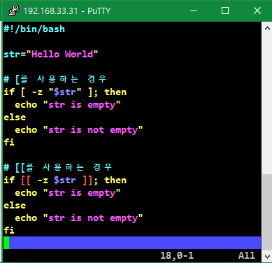
위의 스크립트를 실행하면 다음과 같은 결과가 나옵니다.
str is not empty
str is not empty

마무리
[ 와 [[ 모두 -z 옵션을 사용하여 문자열의 길이가 0인지 검사할 수 있습니다. 하지만 [ 를 사용할 때는 변수에 따옴표를 붙여야 하고, 공백도 잘 지켜야 합니다. [[ 를 사용할 때는 따옴표와 공백을 신경쓰지 않아도 됩니다. 주의 : [[ 도 공백은 띄워야한다.

7. [] [[]] () (()) 차이

https://www.baeldung.com/linux/bash-single-vs-double-brackets

Differences Between Single and Double Brackets in Bash
Last updated: July 25, 2022

Written by: Burak Gökmen
- Scripting
- bash

1. Overview

While comparing variables in Bash, we generally use single brackets ([ ]) and double brackets ([[ ]]) interchangeably.
For example, we can use the expressions [ 3 -eq 3 ] or [[ 3 -eq 3 ]] while checking whether 3 is equal to 3. Both will be successful in performing the comparison. So, what’s the difference between them?
In this tutorial, we’ll discuss the differences between single and double brackets in Bash.

2. Main Differences

In this section, we’ll briefly discuss the main differences between single and double brackets.

2.1. Single Brackets

[ is a shell built-in command that has always been available in Unix and Linux to evaluate expressions. It still exists for backward compatibility and POSIX compliance.
Let’s verify that [ is a shell built-in command using the type command:
$ type [
[ is a shell builtin
[ is an alternative command for the test built-in command. We can use them interchangeably:
$ [ 3 -eq 3 ] && echo “Numbers are equal”
Numbers are equal
$ test 3 -eq 3 && echo “Numbers are equal”
Numbers are equal
The only difference between [ and test is that we must use the closing ] for surrounding the comparison.

2.2. Double Brackets

The double brackets, [[ ]], were introduced in the Korn Shell as an enhancement that makes it easier to use in tests in shell scripts. We can think of it as a convenient alternative to single brackets.
It’s available in many shells like Bash and zsh. However, double brackets aren’t POSIX compliant.
[[ is a shell keyword. Let’s check it using the type command:
$ type [[
[[ is a shell keyword

3. Other Differences

In this section, we’ll discuss the other differences between single and double brackets.

3.1. Comparison Operators

It’s possible to use the comparison operators with the double brackets. Let’s use the less than operator (<) for string comparison:
$ [[ 1 < 2 ]] && echo “1 is less than 2”
1 is less than 2
Here, we checked whether 1 is less than 2 using the less than operator. The comparison was successful. However, using single brackets instead of double brackets will give a syntax error:
$ [ 1 < 2 ] && echo “1 is less than 2”
bash: 2: No such file or directory
In this case, Bash treated the < operator as a file redirection operator. Therefore, we must use the escape character (\) before the < operator for a successful comparison within single brackets:
$ [ 1 \< 2 ] && echo “1 is less than 2”
1 is less than 2
Now, the comparison using single brackets was successful.
Similarly, we must use the escape character before the greater than operator (>) for string comparison within single brackets.
The usage of the integer comparison operators such as -eq, -ne, -gt, -lt, -ge, and -le is the same for both.

3.2. Boolean Operators

We must use the && operator for the logical AND operation and the || operator for the logical OR operation while using the double brackets.
Let’s check that 3 is equal to 3, and 4 is equal to 4:
$ [[ 3 -eq 3 && 4 -eq 4 ]] && echo “Numbers are equal”
Numbers are equal
However, we must use the -o and -a test operators for the logical OR and logical AND operations, respectively, while using single brackets.
Let’s repeat the last comparison we performed using single brackets this time:
$ [ 3 -eq 3 -a 4 -eq 4 ] && echo “Numbers are equal”
Numbers are equal
The comparison is again successful. But we used -a instead of && because of single brackets.

3.3. Grouping Expressions

We can group expressions within the double brackets using parentheses. One reason for grouping may be reading the expressions more easily:
$ [[ 3 -eq 3 && (2 -eq 2 && 1 -eq 1) ]] && echo “Parentheses can be used”
Parentheses can be used
Here, we grouped the expression, 2 -eq 2 && 1 -eq 1, using the parentheses. Then, we used the grouped expression, (2 -eq 2 && 1 -eq 1), as the second expression of && within the double brackets. The first expression of && was 3 -eq 3. The grouping was successful.
Now, let’s use the same expression using single brackets:
$ [ 3 -eq 3 -a (2 -eq 2 -a 1 -eq 1) ] && echo “Parentheses can be used”
bash: syntax error near unexpected token ‘(‘
We used -a instead of && because of single brackets. However, we got a syntax error.
We must use the escape character before the opening and closing parentheses for a successful grouping. There must also be a space after and before the opening and closing parentheses:
$ [ 3 -eq 3 -a \( 2 -eq 2 -a 1 -eq 1 \) ] && echo “Parentheses can be used”
Parentheses can be used
Grouping the expressions using the parentheses within single brackets was successful in this case.

3.4. Pattern Matching

It’s possible to use pattern matching with the double brackets. For example, we can use the wildcard * (asterisk) within the double brackets:
$ name=”Alice”
$ [[ $name = *c* ]] && echo “Name includes c”
Name includes c
$ echo $?
0
Here, we first assigned the value Alice to the shell variable name using the statement name=”Alice”. Then, we checked whether the variable name includes the letter c using [[ $name = *c* ]]. * means zero or more characters. The result was successful, as expected.
However, it isn’t possible to use pattern matching within single brackets:
$ name=”Alice”
$ [ $name = *c* ] && echo “Name includes c”
$ echo $?
1
In this case, the only difference between the previous example is the single brackets. We replaced the double brackets in the previous example with the single brackets. There weren’t any syntax errors, but pattern matching was unsuccessful as the exit status of [ $name = *c* ] && echo “Name includes c” was 1.

3.5. Regular Expressions

It’s also possible to use regular expressions within the double brackets:
$ name=”Alice”
$ [[ $name =~ ^Ali ]] && echo ”Regular expressions can be used”
Regular expressions can be used
We first assigned the value Alice to the shell variable name using the statement name=”Alice”. Then, we checked whether the variable name starts with Ali using [[ $name =~ ^Ali ]]. The =~ built-in operator is used for matching the regular expressions. The caret (^) matches the beginning of a word. Hence ^Ali means the words beginning with Ali. As it’s apparent from the output, we could detect that the value of the shell variable starts with Ali.
Let’s try the same regular expression pattern using single brackets:
$ name=”Alice”
$ [ $name =~ ^Ali ] && echo ”Regular expressions can be used”
bash: [: =~: binary operator expected
Now, we got an error. So, it isn’t possible to use regular expressions within single brackets.

3.6. Word Splitting

Bash doesn’t perform word splitting inside double brackets. For example, if a variable has a string value containing spaces, Bash doesn’t split the string into words:
$ filename=”nonexistent file”
$ [[ ! -e $filename ]] && echo ”File doesn’t exist”
File doesn’t exist
Here, we checked the existence of the file nonexistent file. The filename includes a space. We could directly use the variable, filename, within the double brackets as the double brackets didn’t split the filename.
Let’s try it with single brackets:
$ filename=”nonexistent file”
$ [ ! -e $filename ] && echo ”File doesn’t exist”
bash: [: nonexistent: binary operator expected
We got an error in this case since the filename nonexistent file was split into two words, nonexistent and file. This is related to the IFS variable. If IFS isn’t set, the shell splits the string when it encounters a space, tab, or newline.
We must put the variable in double quotes if we want to prevent the word splitting within single brackets:
$ filename=”nonexistent file”
$ [ ! -e “$filename” ] && echo ”File doesn’t exist”
File doesn’t exist
Now, checking the existence of a filename containing spaces was successful within single brackets.

4. Conclusion

In this article, we discussed the differences between single and double brackets in Bash.
The single bracket is a built-in command that’s older than the double bracket. The double bracket is an enhanced version of the single bracket. If we want the portability of scripts, we should prefer single brackets. However, using the double brackets is generally more convenient.
We saw that we could use comparison operators and boolean operators in both, apart from a few differences. The same thing is valid for grouping expressions and word splitting. However, using pattern matching and regular expressions is only possible in the double brackets.

예:) [[]]도 명령어창에 단독으로 쓸 수 있다. (== test)

[kimnux@archlinux ~]$ [[ 5 -gt 3 ]] && echo 'wow'
wow
[kimnux@archlinux ~]$ [[ 5 -lt 3 ]] && echo 'wow'
[kimnux@archlinux ~]$

8. 쉘 특수문자: 공백,{} 하나의 명령,[], exit, return, ${} 확장, (( )) let 산술연산, $()

https://velog.io/@markyang92/bash-shell-special-variable

9. Flag 의 의미
프로그래밍에서, 플래그는 무엇인가를 기억해야하거나 또는 다른 프로그램에게 약속된 신호를 남기기 위한 용도로 프로그램에 의해 사용되는 미리 정의된 비트를 말한다.
플래그들은 컴퓨터 프로그래밍에서 매우 자주 사용된다.
http://terms.co.kr/flag.htm
위 본문에는 이해 하기 어려운 글이 있어서 일부 삭제 했습니다.

두가지 부울 값을 가지는 상태를 표현 할 때에 플래그를 많이 사용 합니다.
예를들면
스위치가 1이면 팬을 동작 시키고
스위치가 0이면 팬을 정지 시킨 다고 할 때에

bit sw_flag=0; //초기값

if(sw==0)sw_flag=1; // 스위치가 눌리면 플래그를 set
else sw_flag=0;

if(sw_flag)FAN=1; // 스위치 플래그가 1이면 팬 ON
else FAN=0;

이런 식으로 사용 합니다.
물론 AVR 컴파일러에서도 코드비젼만 비트 변수를 지원 하므로
타 컴파일러에서는 비트 변수 대신 char 나 int를 사용 해서 플래그 변수를 만듭니다.

두가지 상태가 아닌 여러가지 상태를 가질 때에는
status 라는 이름의 변수를 많이 사용 합니다.
예) key_status, led_status등

flag 변수명으로 status 처럼 사용 하는 사람도 있고
status 변수명으로 flag 처럼 사용 하는 사람도 있습니다.​

특수 변수 $0, $1, $2, $*,$@

개요
- Shell에서 $0, $1, $2, $*, $@, $# 는 특별한 의미를 갖음
특수 변수 | 설명
$0 | Script를 실행시킬 때 프로그램의 이름이 포함된 첫 번째 문자열을 저장
$1, ...$N | 입력 값들이 순서대로 저장되며, 위치 매개변수(Positional Parameter)라고 표현
$* | 모든 위치 매개변수를 담고 있는 단일 문자열
$@ | $* 과 비슷하나 $@는 "$1", ..."$N"을 의미
$# | 위치 매개변수의 개수를 저장
$? | 쉘에서 최근 실행한 명령어의 종료 상태를 담은 변수
$$ | 쉘 스크립트의 프로세스 ID를 저장
$_ | 마지막 인수를 출력하는 변수를 저장

실습

$0, $1, $2, $*, $@, $#
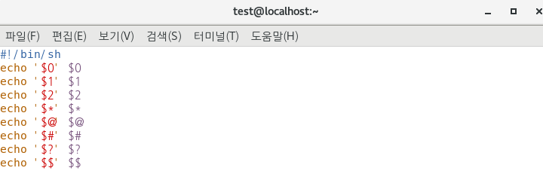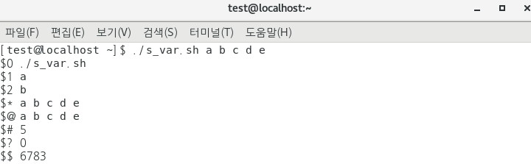
- $0 : 첫번째 문자열이 저장되기 때문에 실행 명령어인 ./s_var.sh를 저장
./s_var.sh a b c d e
- $1, $2 : 실행 명령어를 제외, 차례대로 위치에 따라 매개변수를 저장
./s_var.sh a b c d e
- $* : 모든 위치 매개변수를 담은 문자열 저장
./s_var.sh a b c d e
- $@ : $1 ~ $N 위치의 매개변수를 저장
./s_var.sh a b c d e
- $# : 위치 매개변수 개수 5개를 저장
./s_var.sh a b c d e
- $? : 최근 명령어의 종료 상태 저장
(0) -> 명령어 종료 상태 정상
- $$ : 스크립트의 PID 저장

' ' 구분자
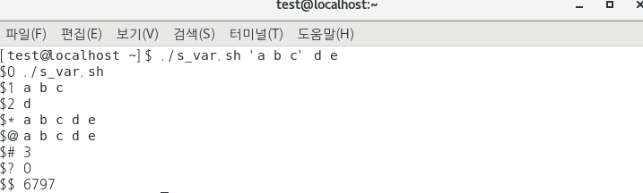
- 띄어쓰기를 구분자로 위치 매개변수를 저장
- 변수 내 띄어쓰기가 필요한 경우 구분자인 ' ' 사용
./s_var.sh 'a b c' d e

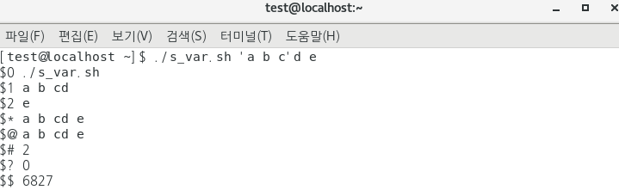
- 띄어쓰기를 구분자로 'a b c'와 d 사이 띄어쓰기가 없어 a b cd로 $1에 저장됨

$?
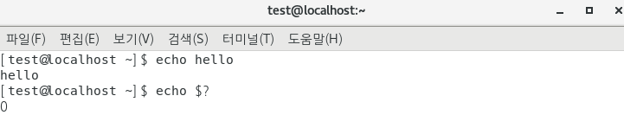
- 최근 명령어의 종료 상태가 정상(0)일 경우

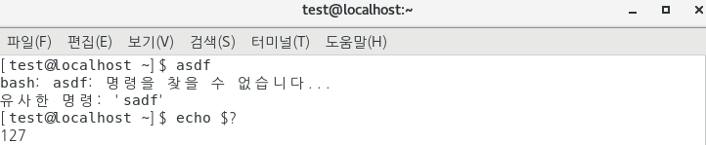
- 최근 명령어의 종료 상태가 비정상 일 경우

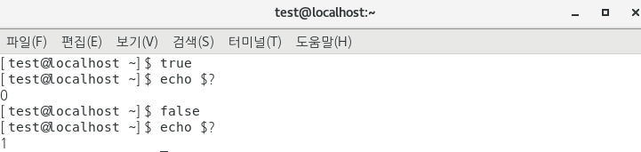
- true / false에 대한 명령어 상태 (0) / (1)

$_
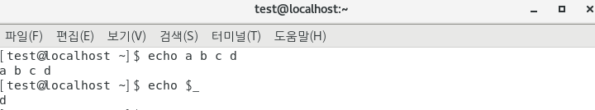
- 마지막 위치 매개변수 저장
./s_var.sh a b c d
Configuration files

File | Description | Login shells (see note) | Interactive, non-login shells
/etc/profile | Sources application settings in /etc/profile.d/*.sh and /etc/bash.bashrc. | Yes | No
~/.bash_profile | Per-user, after /etc/profile. If this file does not exist, ~/.bash_login and ~/.profile are checked in that order. The skeleton file /etc/skel/.bash_profile also sources ~/.bashrc. | Yes | No
~/.bash_logout | Per-user, after exit of a login shell. | Yes | No
/etc/bash.bash_logout | Depends on the -DSYS_BASH_LOGOUT="/etc/bash.bash_logout" compilation flag. After exit of a login shell. | Yes | No
/etc/bash.bashrc | Depends on the -DSYS_BASHRC="/etc/bash.bashrc" compilation flag. Sources /usr/share/bash-completion/bash_completion. | No | Yes
~/.bashrc | Per-user, after /etc/bash.bashrc. | No | Yes

History Command
- 설정
- 사용
- References
Command line에서 명령을 실행하면 해당 명령이 기록에 남는다. 이 기록을 살펴보는 명령이 history다.

설정
이 설정은 bash기준이며 다른 쉘에서는 약간 다를 수 있다.1
export HISTTIMEFORMAT='%F %T ' # 로그에 날짜와 시간 출력
export HISTIGNORE="pwd:ls:ls -ltr:" # pwd, ls, ls -ltr명령은 로그에 기록하지 않는다.
export HISTCONTROL=ignorespace # 명령 실행시 처음 스페이스가 포함되면 로그에 기록하지 않는다.
export HISTCONTROL=ignoredups # 명령이 중복되면 무시 (pwd를 연속으로 여러번 입력하면 로그에는 pwd하나만 기록된다)
export HISTCONTROL=erasedups # 중복로그를 삭제하고 최근로그만 남긴다.
export HISTSIZE=450 # 저장할 로그 개수 지정 (0을 지정하면 history 기능이 disable된다)
export HISTFILESIZE=450 # 저장할 로그 개수 지정
export HISTFILE=/root/.commandline_warrior # 히스토리 로그 파일 변경

사용
- Ctrl+R을 사용하여 history명령을 활용할 수 있다. Enter를 치면 검색한 명령이 수행된다. Backspace로 검색어를 삭제한뒤 재검색할 수 있다. 수정이 필요하면 esc나 화살키를 사용한다.
  - (reverse-i-search)`':
- 키보드의 Up키나 Down키 또는 Ctrl+P나 Ctrl+N으로 이전명령 다음명령을 선택하여 재실행 할 수 있다.
- !! or !-1 바로 이전 명령을 재실행 한다.
- ![no]로 history number에 해당하는 명령을 재실행 한다.
- ![keyword]로 가장 최근의 키워드로 검색하여 재실행한다.
- vi !!:$ 이전명령의 마지막 인자 활용
- vi !!:[no] 이전명령의 [no]인자 활용
- vi !^ 이전명령의 첫번째 인자 활용
- ls -l !cp:2 최근 사용한 cp명령의 두번째 인자 활용
- history 53 53부터 마지막까지 로그 출력
- history -10 마지막부터 10개까지 로그 출력
- history -c를 하면 히스토리기록을 모두 삭제한다.
expr, $(()), (())
참고 : https://www.networkworld.com/article/965568/how-to-do-math-on-the-linux-command-line.html

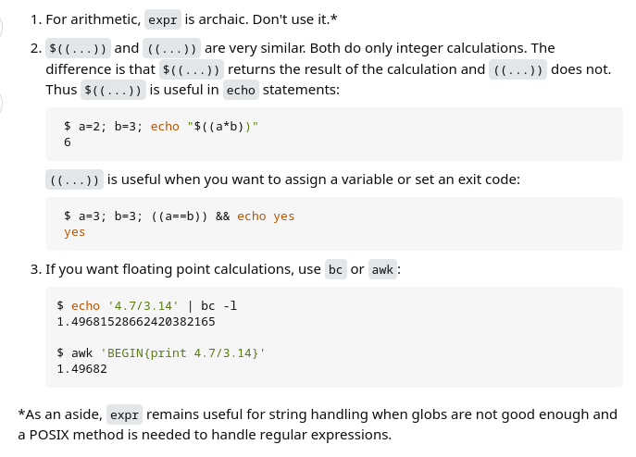
ex) echo $((2+3))
5
ex) a=2.1; b=3; echo “$a+$b” | bc
5.1
ex) a=3; b=4; echo “$((a+b))”
7

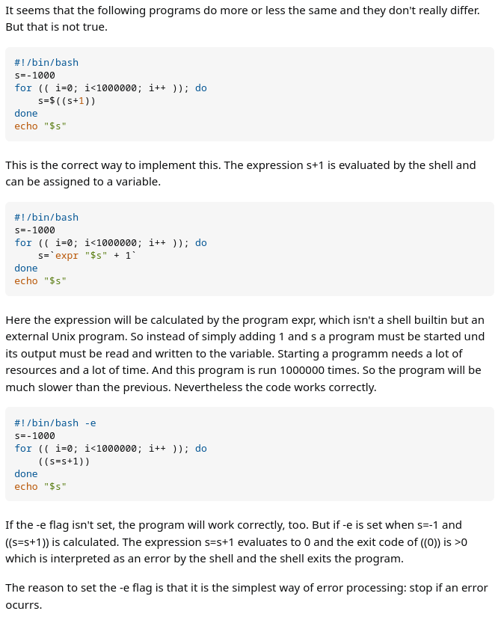

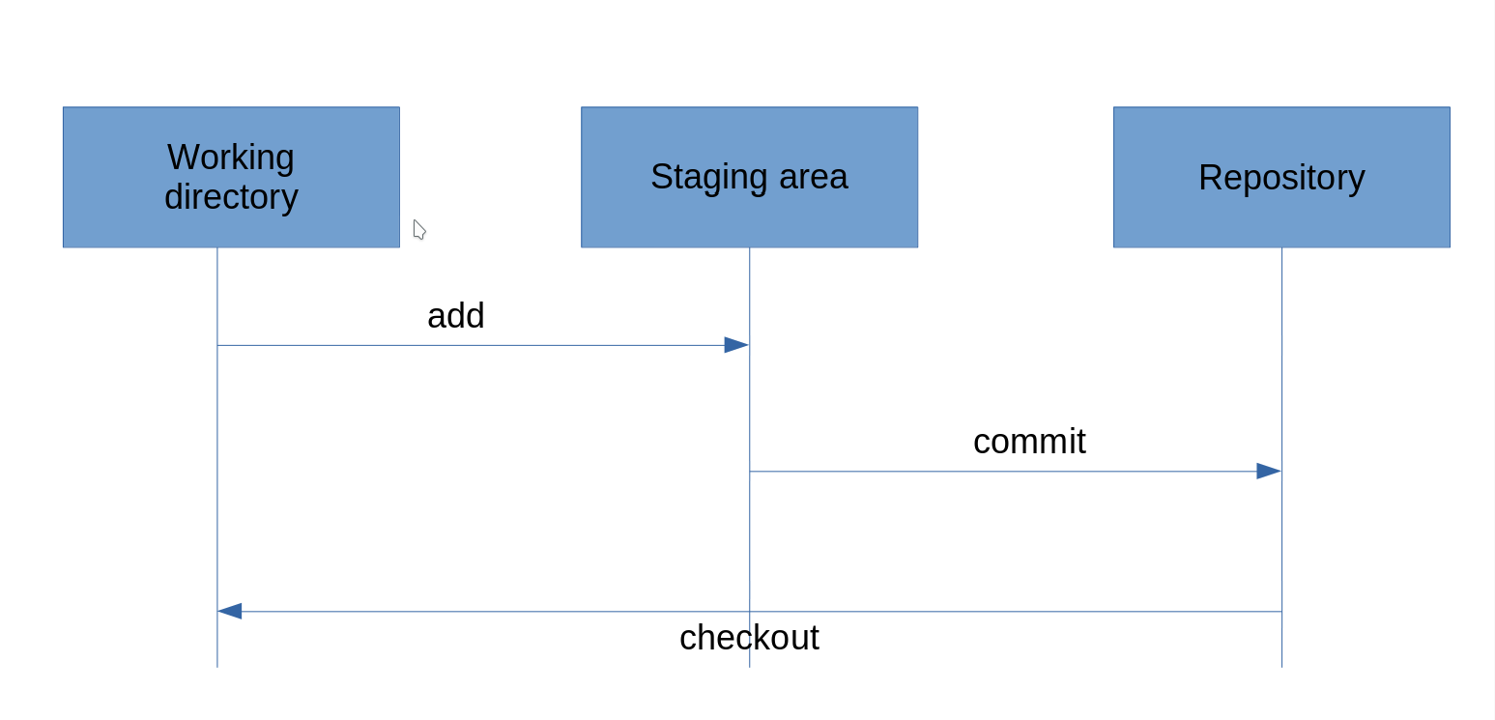
Git repository

여러 이름의 파일 동시에 cp, mv 하기

ex) X나 x로 시작하는 파일들을 한번에 ./txt디렉토리로 cp하기

find . -type f -iname 'x*' | xargs -i cp {} ./txt

Grep command option
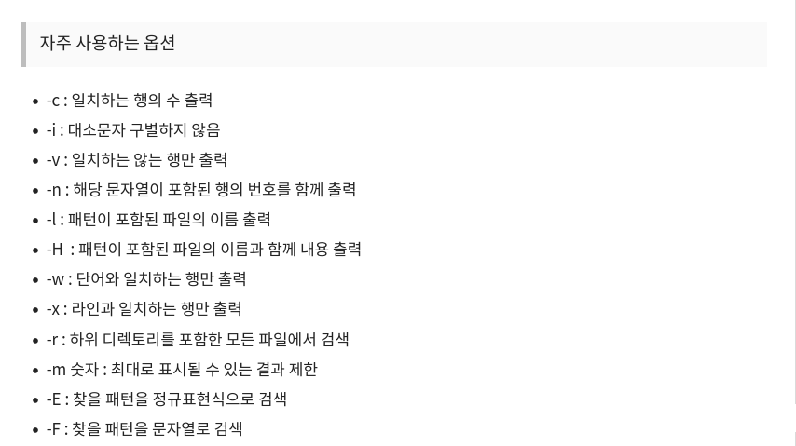
-o : only-matching
ex) grep -Ewo

word boundary
https://www.regular-expressions.info/wordboundaries.html
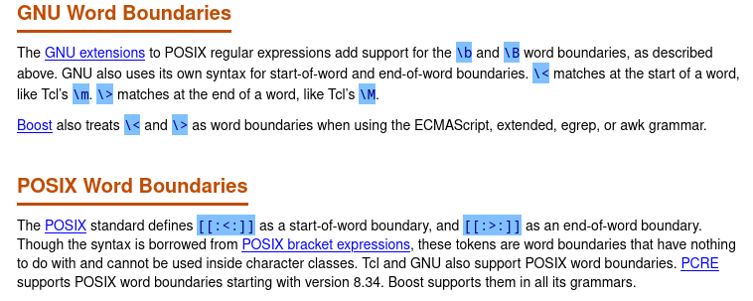
https://ko.javascript.info/regexp-boundary

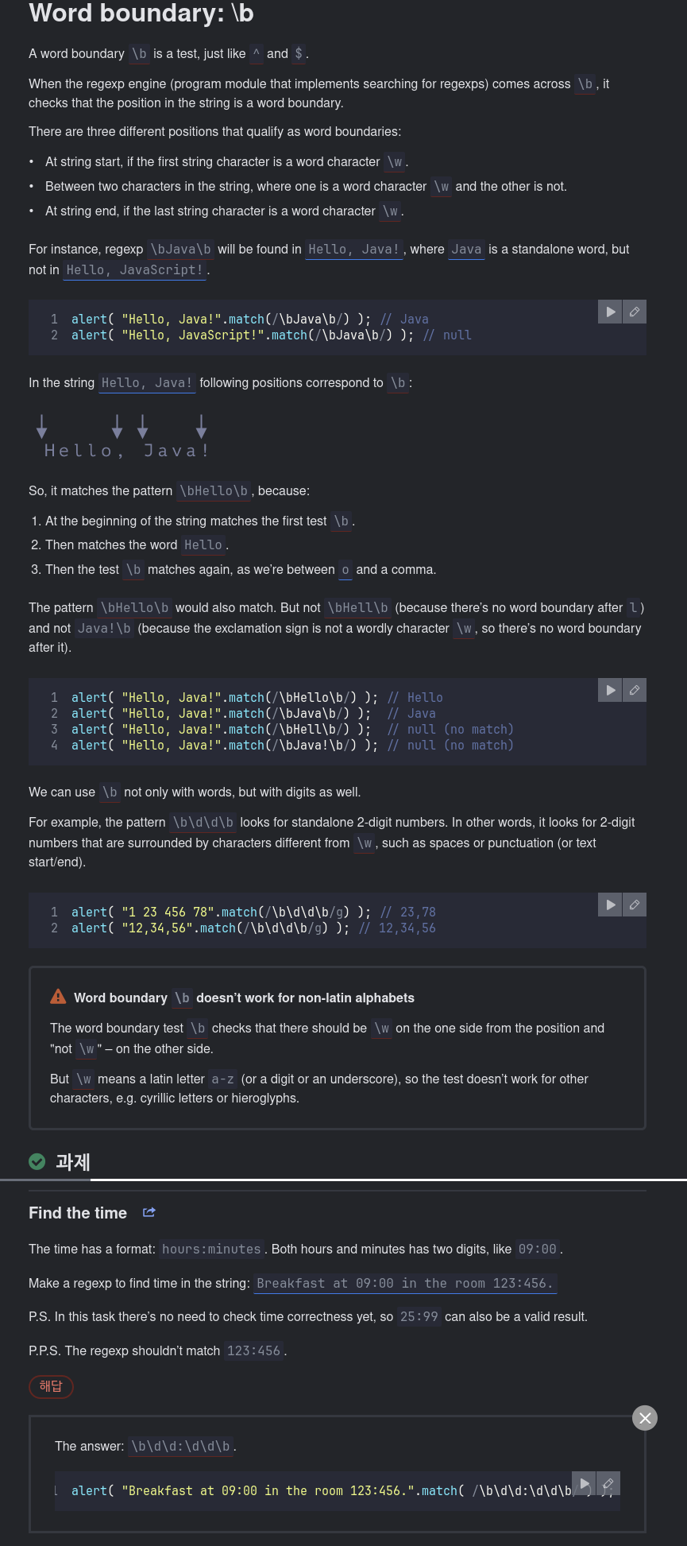

\b \> \< 의 차이점
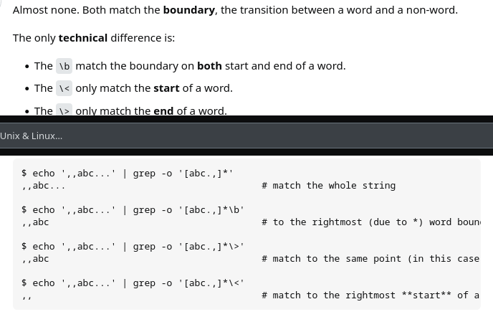
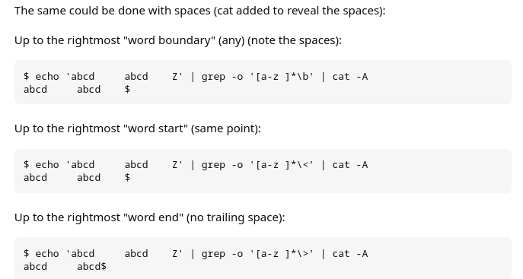

~
➜ grep -E '[ae]' test.txt # 각 character에서 e나 a를 검색 (둘 중에 하나 검색)
gray grey greay graey

~
➜ grep -E 'gr[ae]y' test.txt # gr로 시작하고 y로 끝나는 4글자 단어 중에서 e나 a가 들어간 단어검색
gray grey greay graey

~
➜ grep -E 'gr[ae][ae]*y' test.txt #gr로 시작하고 y로 끝나는 4글자 이상의 단어중에서 검색
gray grey greay graey

~
➜ grep -E 'gr[ae][ae]y' test.txt #gr로 시작하고 y로 끝나는 4글자 단어중에서 검색
gray grey greay graey

~
➜ grep -E 'gr[ae][ae]?y' test.txt #gr로 시작하고 y로 끝나는 3글자 혹은 4글자 단어중에서 검색
gray grey greay graey

단어 경계는 \w와 \W의 그 사이를 찾는 작업
https://choonse.com/2022/06/01/1033/
정규표현식(regular expression)을 사용해 일치(match)하는 단어나 기호를 찾는 것은 매우 간단합니다.
My name is ABC.
ABC는 정규표현식 /ABC/를 사용하면 간단하게 찾을 수 있습니다.
그러나 다음 문자열에서 to를 찾기 위해 /to/를 사용하면 의도한 결과를 벗어납니다.
She told me not to go.
to가 포함된 모든 단어를 검색하는데요.
이 때 /b를 사용해 경계를 지정하면 원하는 부분만 찾을 수 있습니다.
그렇다면 /b의 정확한 기능은 무엇일까요?

1. /b의 기능
/b는 문자(\w에 해당하는 문자, a-z,A-Z,0-9,_)와 비(非)문자(\W에 해당하는 경우) 부분의 경계를 의미합니다.
이 부분의 이해가 어려울 수도 있는데요.
예를 들어 보겠습니다.
문자(\w로 표현): abcdefzhijklmnopqrstuvwxyzABCDEFGHIJKLMNOPQRSTUVWXYZ0123456789_
비문자(W로 표현) : 위 문자를 제외한 모든 기호
위와 같은 정의를 갖는 문자와 비문자 사이의 경계를 나타냅니다.
참고로 문자의 \w는 w가 소문자, 비문자의 \W는 대문자입니다.
띄워쓰기는 비문자에 해당하므로 /b를 사용해 단어의 경계를 정하고 원하는 결과를 만들 수 있는 것입니다.
그럼 다음 상황을 확인해보죠.
/\ba/g
위 표현식을 사용했을 때 다음 문자열에서 찾을 수 있는 결과는 무엇일까요?
-a
‘ a’
_a
aa
star
결과는 다음과 같으며 한 줄로 표현하겠습니다.
–a ‘ a‘ _a aa star
-a에서 a가 선택되는 이유는 -가 비문자이며 a가 문자이므로 \b는 두 사이를 가리키기 때문입니다.
‘ a’에서도 a 앞의 띄워쓰기는 비문자, a는 문자이므로 \b는 두 사이를 가리킵니다.
_a에서 a가 선택되지 않는 이유는 _ 기호는 문자로 취급하며 a도 문자이기 때문입니다.(\w의 정의)
aa에서 a가 선택된 이유는 문자열 제일 앞 또는 제일 뒤가 문자면 \b의 조건에 해당한다고 정의하기 때문입니다.
따라서 위의 문장에서 to만 찾으려면 다음과 같은 표현식을 사용하면 됩니다.
/\bto\b/g
She told me not to go.
참고로 \b, \B는 경계만을 가리킬 뿐 실제 문자와 일치하는 것은 아니므로 결과에는 포함되지 않습니다.

2. /B의 기능
그렇다면 대문자로 표현되는 \b의 반대 기능 \B의 정의는 무엇일까요?
바로 비문자와 비문자 사이의 경계, 또는 문자와 문자 사이의 경계를 의미합니다.
!-! abc와 같은 비문자 사이에서 비문자(-)를 찾거나 문자 사이에서 문자(b)를 찾을 수 있습니다.
/\B-\B/g
!-! ‘-‘

3. 활용
\b, \B는 주로 단어 검색에 유용합니다.
이 기능의 명칭이 단어 경계(word boundary)이므로 용도는 명확합니다.
문자열 내 의도하지 않은 기호의 탐색이나 카멜케이스(CamelCase)등과 관련된 작업에도 사용할 수 있습니다.

